Shrimp Task Force Meeting
Wednesday, February 16, 2022, 10:00am
LDWF Headquarters
2000 Quail Dr.
Baton Rouge, LA

I. Pledge of Allegiance
II. Roll Call
Voting Members Present:
Rodney Olander
Acy Cooper
Lance Nacio
Kristen Baumer
Randy Pearce

Voting Members Absent:
Jeff Drury
Ronald Anderson
Philip Tran
Andrew Blanchard
Alan Gibson
Chalin Delaune

Non-Voting Members Present:
Peyton Cagle
Davis Madere in for Bryan Marie
Jack Isaacs
Gene Cavalier

Non-Voting Members Absent:
Adam Eitmann
Justin Gremillion

III. Lance Nacio motioned to approve the December 8, 2021 meeting minutes, 2nd by Kristen Baumer. Motion carries.

IV. Acy Cooper motioned to add an item to the agenda under New Business, B. To Discuss a Proposal to Hire a Lobbyist to Represent the Shrimp Task Force, 2nd Kristen Baumer. Motion carries.

Kristen Baumer motioned to postpone item B. Officer Elections and replace it by adding an item to the agenda, C. To Discuss the USDA’s Covid-19 Seafood Processors Grant Program, 2nd Acy Cooper. Motion carries.

Acy Cooper motioned to approve the February 16, 2022 meeting agenda as amended, 2nd by Lance Nacio. Motion carries.

V. Financial Report
Remaining Fund Balance- $677,406
Remaining Budget Balance- $47,126

Lance Nacio motioned to approve the financial report, 2nd by Kristen Baumer. Motion carries.

VI. New Business:
- Scott St. John from the Attorney General’s Office provided a status update and led discussion in a closed executive session on litigation strategy in the matter of State of Louisiana, by and through Louisiana Department of Wildlife and Fisheries versus Gina Raimondo, in her official capacity as United States Secretary of Commerce, et al., C.A. No. 21-1523, Section “R” (2), U.S.D.C., Eastern District of Louisiana
Acy Cooper motioned for the board to go into executive session, 2nd by Kristen Baumer. Motion carries with roll call vote, all board members in favor
Board discussed ongoing litigation and strategies moving forward
Acy Cooper motioned to go out of executive session, 2nd by Kristen Baumer. Motion carries.
- The task force discussed hiring a lobbyist to represent the board and the industry
American Strategic Partners, Brian Shinault, CEO- based in Washington, D.C. and Louisiana
Acy Cooper stated that since the Governor’s Office has not been represented at the STF meetings, this would be the perfect opportunity to have the industry’s concerns heard, since they have good ties to the Governor’s Office and in Washington, D.C. would like to put a proposal in to the board and propose costs
Brian Shinault would present proposal in writing with a couple of options will need specific issues and concerns from the industry and based on that will develop a strategy. Will follow up with a more detailed email to find out some of the concerns and will structure a proposal and provide the committee with some options from there. From LA with a great interest in the seafood industry and have some history, spoke about funding opportunities, American Strategic Partners has a grant division and a team that prepares seeking out funding opportunities, would like the task force to submit a few issues and concerns
Rodney Olander requested that ASP come back to a future meeting with a proposal after feedback is received from the industry
Kristen Baumer stated the most need is at the State level, give us a chance to provide a few points together locally and get back to him on where they can help most
Cole Garrett stated that there are restrictions both in the constitution and in statute, specifically prohibiting the use of state funds to lobby the state legislature. It is understood that the desire is to affect issues at the state level and there are ways to do it. Some examples: The LA Oyster Dealers and Growers Association have hired their own with private funds and they have a lobbying presence there through their industry group. We have precedent in this with the alligator industry to hire lobbyist at the federal level to coordinate and keep us up-to-date on what is going on in DC- There are no prohibitions in state law against that, but there are prohibitions for lobbying the state legislator. If this is something that the task force wants to move forward with there is a process of procurement getting professional services has to go through the Office of State Purchasing and there are some levels of review/ approvals
- The task force discussed USDA’s Covid-19 Seafood Processors Grant Program
The U.S. Department of Agriculture (USDA) announced an investment of $4,229,669 in grant funds to support Louisiana seafood processors, processing facilities, and processing vessels for expenses related to COVID-19. The Louisiana Department of Agriculture and Forestry’s (LDAF) Louisiana Agricultural Finance Authority (LAFA) has been selected to administer the Louisiana Seafood Processors Pandemic Response and Safety Block Grant Program (LSPPRS) as a result of the grant award. The program is funded by the Pandemic Assistance provided in the Consolidated Appropriations Act of 2021. “As the nation’s second-largest seafood supplier, our producers, distributors, processors, and vessels will greatly benefit from this relief. The last two years have brought plenty of challenges to the industry, including the COVID-19 pandemic but also brutal hurricane seasons,” said LDAF Commissioner Mike Strain, D.V.M. “It’s time to get them back on track and offer some assistance to one of the most important and impactful Louisiana industries.” The grant will be made available to Louisiana residents that possess one of the following Louisiana Department of Wildlife and Fisheries licenses during 2020 and 2021: Residential Wholesale/Retail-Business, Residential Wholesale/Retail-Vehicle, Residential Vessel, and Residential Seafood Retailer/Dealer. It is important to note these funds are not for lost revenue. They are to reimburse businesses for expenses paid during the dates of January 27, 2020, through December 31, 2021. Qualifying expenses must have been for: 1)Workplace Safety Measures - -ex: PPE, sanitizers, handwashing stations, cleaning supplies. 2)Market Pivots - -ex: virtual/online sales costs – website development – credit card processing fees, new signage. 3)Retrofitting Facilities - - to keep workers and consumers safe - - ex: maximizing open-air activities, plexiglass, walkup windows, fans, tents, weights, tables, chairs. 4)Transportation - - additional transportation costs incurred to maintain social distancing – ex: an additional van to allow for one driver at a time or buying a van for deliveries. 5)Worker Housing - - additional housing costs incurred to maintain social distancing or to allow for quarantining of new or exposed employees. 6)Medical - -unreimbursed costs associated with providing or enabling vaccinations, testing, or treatment of infected employees - including paid leave. The application and guidelines for the program are currently being developed. More information will be forthcoming.
- Jason Froeba led discussion on considering changes to the 2019 flood disaster spending plan
NOAA Spend Plan Review:
- Plan was submitted to NOAA in late December 2021
- Initial review was planned to be completed by the end of February 2022
- Review led to a meeting in which LDWF was informed NOAA’s stance on direct payments was not accurately reflected in prior communications
- Direct payments are now a viable option
- LDWF Administration is requesting input from the various Task Forces on whether or not direct payments should be pursued
- Doing so will require changes to the spend plan and minor to moderate delays in getting an approved spending plan

Potential Program Changes:
- Equipment and Marine Aquaculture Grants eliminated
- $26,950,000 allocated to a direct payment program
Potential Eligibility Changes:
- No loss requirement for equipment grants
- Direct payment eligibility requires a revenue loss and recipient cannot receive more than they lost (NOAA requirements)
- Losses based on 2019 income compared to 5 year average from 2014-2018

Next Steps:
- Gather recommendations from task forces and determine if a change will be made
- Any changes must be implemented as quickly as possible
- LDWF is requesting input and a recommendation today

Rodney Olander stated that his second opinion would be- we know which areas were hardest hit, if there are only 1000 people shouldn’t the folks in the most affected areas move up to the top of the list?
Kristen Baumer stated that he would do a little bit of both, split the funding in half and do both a reimbursement program and the other half for direct payments
Acy Cooper stated that people are out there buying stuff thinking they are going to be getting a reimbursement for equipment, cash payments, 10 cents on the dollar is not a whole lot of money either, equipment grants sounds good but when it comes down to it not everyone will qualify
Rodney Olander stated that he is not a fan of proving a loss to receive funding
Acy Cooper stated that certified fishermen should be at the top of the list for all money, asked why are deck hands always left out? Would like to discuss this further in the future
Rocky Decharo stated that he thinks we should leave the funding as it, agrees that affected areas should be top priority
Kristen Baumer stated to leave it like it is
Jason Froeba stated that there is some concern of people buying things and not going to get reimbursed, the way that we come up with the application process the people who want to buy something and the people who already bought something will be in the same boat when it comes to application process
Task Force suggested using the Marine Aquaculture money and use it for a direct payment program
George Barisich stated that lots of people have bought things with the anticipation of being reimbursed and this is a problem
Barry Rogers stated that he is for leaving the program like it originally was, 30K direct payment has already been announced and people went out and bought
Rodney Olander stated that first come first serve has been an issue in the past, certified commercial fishermen and those in the most impacted areas should be first
- The board discussed federal shrimp cELB vs. VMS side-by-side comparison
Federal shrimpers are required to have the ELB A new project is being developed for a study using a new VMS and cellular 3G ELB on board their vessel that tracks it. The 3G signal went out a few years ago so they are having to use SD cards to record their tracks and then every month to every couple of months they have to mail those in. A new project is being developed here for a study using a new VMS and a cellular ELB. Currently looking for volunteers, have volunteers through the whole Gulf states but are missing participants from LA, looking for a LA federal fishermen to volunteer, will be no cost to the individual install different types of gears and find out which one works best, if interested contact Farron Wallace at farron.wallace@noaa.gov, looking for fishermen who use the wind plot system
- The board discussed the shrimp ride along program and protocol
It has been requested that LDWF do the shrimp ride-along program again in the spring. Had a few issues in the past with the protocol not being properly followed. The purpose of the comparison is to allow the industry and LDWF to compare shrimp abundance, diversity, inside structure in a standardized sample in an experimental gear vs commercial gear. The manager of each area that participates, we break it down by major basin, is to choose two degree of their sampling sites and the commercial fishermen that is going to participate is to provide a list of sites. At this point a list is compiled of the commercial fishermen in each area with license information and the sites provided and then the sites to be sampled are drawn at random from this. The participating fishermen will be provided the information on the site ahead of time along with a letter from the LDWF Secretary which allows these fishermen to trawl during closed season to collect the samples. Acy Cooper is the point of contact for this program. Need the list of fishermen by basin, fishermen stations, license information, vessel ID # have all this information in to Peyton Cagle by March 18. Sampling would take place the 2nd week of April, need to stick to the protocol and information needs to be sent in on time
Acy Cooper stated that we need this stuff promptly, don’t want to wait to the last minute, need to complete all sites, if other boats want to participate information needs to be sent to Acy Cooper
Peyton Cagle stated that sites will be visited in order
- Maryam Tabarestani provided a presentation on trends in commercial white and brown shrimp landings by size category: 2010-2020
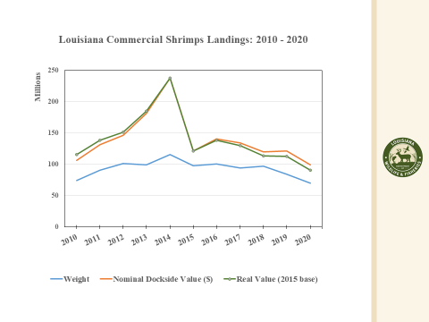
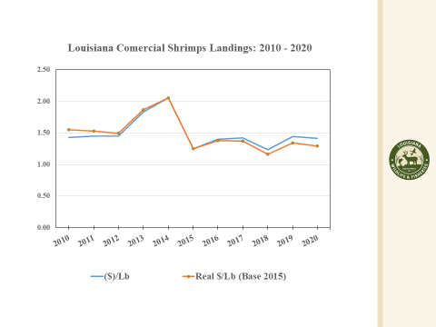
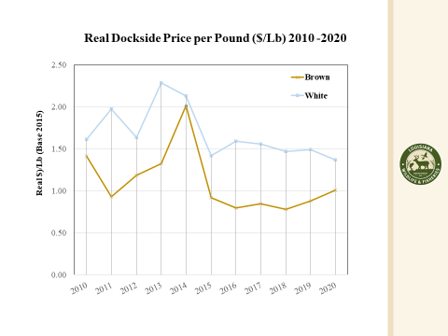
Rocky Decharo requested that Jack Isaacs bring back information to the next meeting on pounds of imported shrimp, 150-220 ct shrimp, and go back 200 years and come back with dockside price
Jack Isaacs imports will be up compared to 2018-2019 and 2020
- Task force took up item K. To Discuss the Shrimp Task Force Washinton, D.C. Trip, at this time
Kristen Baumer provided an update from the trip, board members who were in attendance were, Chalin Delaune, Rodney Olander, Acy Cooper, Kristen Baumer, and Andrew Blanchard. Stated that the board had a ton of meetings with all of the LA delegation, Mississippi, maybe one in Alabama and Georgia, overall it was a good trip, a lot of conversations moving in directions that is for the benefit of the industry, continuing imposing inspections on imports, country of origin labeling, USDA purchase, funding available to go through USDA partner seafood with farming and agriculture, TEDs, there is a line of work going on behind the scene, need to make more of an effort to go to D.C. more often throughout the year
George Barisich stated that Congressman Higgins developed his own legislation, when he does launch it if anyone has connections with senators we need to make some connections, the legislation is for American producers
Jack Isaacs stated that there is an article on IUU fishing, it’s illegal, unreported, and unregulated fishing- put together a list of references, one reference was from the International Trade Commission, and they came up with estimates on the amount of imports coming into the US that fall into this category, there is a special section on shrimp, something to consider when visiting D.C.
- Brian Lezina provided an update on the schedule and mitigation plan for the proposed Mid-Barataria Sediment Diversion
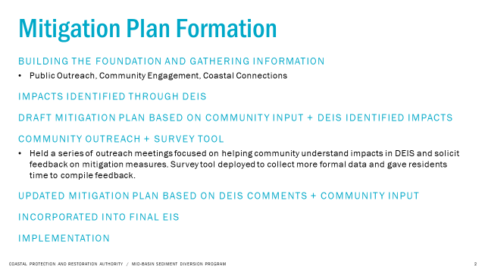
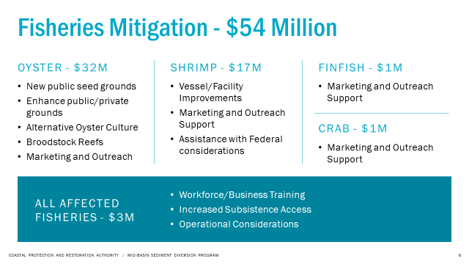
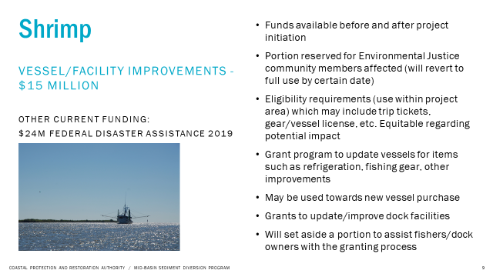
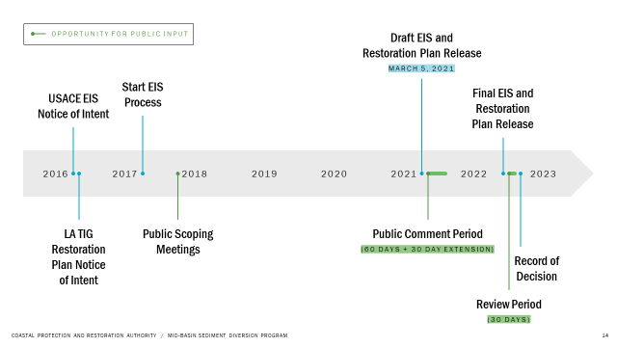
George Barisich stated that the spillway was opened for a 48 day event and this produced a $365M loss… how is a $54M mitigation plan is equitable for the whole seafood industry? If you want to talk compensation
Barry Rogers stated that he is under the assumption that this diversion project is to build land, advised to go look at South Pass and see the work that is being done by dredging 1 small estuary, built 10ft of land, in Lafitte building miles of land, if CPRA really wants to build land this is not going to work, if you want to build land dredge the MS River
- The task force heard a presentation on offshore wind development in the Gulf, Tershara Matthews, Chief of Emerging Programs, Gulf of Mexico Regional Office provided the presentation
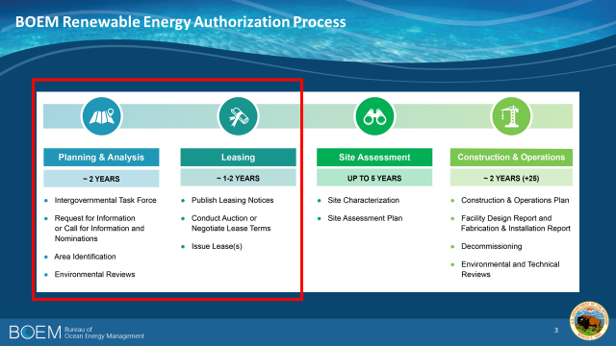
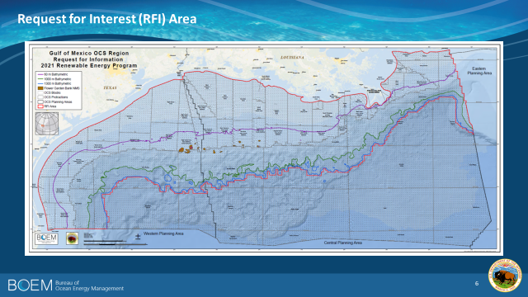
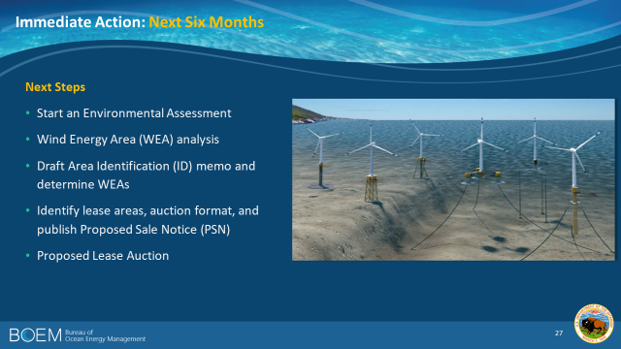
BOEM received a letter from the LSA and LA Shrimp Alliance on this and have some feedback on questions submitted
Rodney Olander asked if this will even be cost effective? Can use the same workforce jackets from the oil/gas industry so it is, green hydrogen, seem to think there is an economic viability in the Gulf
How many acres in La? Working with NOAA to utilize fisheries data, typical windfarm is 80K acre, Working with NOAA to determine the heavily worked areas, and trending up areas using a model, Project will be no closer than 3 nautical miles out, probably going to go at least 20 nautical miles out, near Port Fouchon, there is a lot of infrastructure, no inshore projects
- The board discussed 3-mile closures in parts of zone 2
Thomas Olander LSA chairman, here to petition STF to get in touch with the LDWF Secretary to see if there can be an immediate reopening of this area, why is just this area closed down and not the whole state? In 2019/2020 the fishermen in this area, where they closed the Gulf down, had to go to Cocodrie to fish, on October 18 had to shutdown in the inland waters, on January 14 went in Gulf and caught 2900 lbs of shrimp and then 10 days later closed Gulf, on February 5 where it’s the same depth and temperature not able to even get 100 days of fishing any more, now is the opportunity for fishermen to make money and our area is being closed down, why are we allowing this to be done, asking for the STF to write a letter to LDWF Secretary to request the immediately reopening of this
Acy Cooper stated that he called to talk to the LDWF Secretary about this issue and said that there was a federal issue
Rodney Olander stated that until the Wax Lake outlet is closed should not have a closure in zone 2
Peyton Cagle stated that the closure is based on data, when the offshore landing data indicates an average size over a 100ct, which is an illegal size, it is recommended to close the area to protect the juvenile white shrimp. Talked about doing a special opening, but the majority of calls made, the opinion was not to open
- Item postponed to future meeting, to hear a presentation on the LA search for National Estuarine Research Reserve

- The task force heard an update on funding for Gulf hypoxia
Draft Resolution – Louisiana Shrimp Task Force November 2018
Statement of support for continued efforts by the State of Louisiana to address the problem of the Gulf of Mexico Hypoxic Zone
WHEREAS, Louisiana’s coastal fisheries are a vital part of the state’s economy, with the shrimp industry alone accounting for 15,000 jobs and an economic impact of $1.3 billion;* and
WHEREAS, the large area of low oxygen or hypoxia that forms each year in Louisiana’s coastal waters is an issue of concern for the state’s seafood and fishing industries, including shrimp harvests in offshore waters influenced by the Mississippi and Atchafalaya Rivers; and
WHEREAS, the low oxygen levels are caused by loading of nutrients from the Mississippi River Basin, and reducing the growth of Gulf hypoxia requires lowering those inputs by reducing nutrient loading into the Mississippi and Atchafalaya Rivers and the Gulf; and
WHEREAS, the state of Louisiana, along with 12 other states along the Mississippi and Ohio Rivers, as well as federal agencies, stakeholders, and researchers, has been working to address this problem since 1997 as part of the national Gulf Hypoxia Task Force; and
WHEREAS, the agreement by all these parties in the Gulf Hypoxia Action Plan calls for reaching a 20% reduction in nutrient loading to the Gulf of Mexico from the Mississippi and Atchafalaya Rivers by the year 2025 through their joint efforts, and reducing the average annual size of the Gulf Hypoxic Zone to 5000 square kilometers/1950 square miles by the year 2035; and
WHEREAS, working to reach this Target and Goal represents a commitment by Louisiana and other states and agencies, and will also benefit fishing, seafood, and general water quality in the bays, estuaries, and coastal waters of Louisiana;
THEREFORE, the Louisiana Shrimp Task Force expresses its support for the continued effort by Louisiana and the states and agencies on the Gulf Hypoxia Task Force to achieve the target and goal agreed to in the Action Plan for Reducing Hypoxia in the Gulf of Mexico.
*Figures from Louisiana Seafood Board (https://www.louisianaseafood.com/industry)
VII. Public Comment:
David Chauvin stated that two biggest issues fuel and shrimp prices, send someone to a restaurant and DNA sample to determine if shrimp is domestic or not, could the task force facilitate something like that, suggested that the task force consider this, $35 for DNA sample, bring awareness around this issue; Chain of custody to prove that the shrimp came from where you got it from, a lot of background to do this and then get a grant
VIII. Next meeting set for Wednesday, April 20, 2022 for 10am at the Terrebonne Parish Main Library, also scheduled a Zoom meeting for Wednesday, May 4, 2022 for 1pm to discuss season
IX. Meeting adjourned, no motion was made as quorum was lost prior to adjournment

